**CMSC203 Assignment 0**

Class: CMSC203 CRN [**2**](https://bb-montgomerycollege.blackboard.com/webapps/blackboard/execute/courseMain?course_id=_104851_1)**430**[**7**](https://bb-montgomerycollege.blackboard.com/webapps/blackboard/execute/courseMain?course_id=_104851_1)

 Program: Assignment 0

Instructor:

 Summary of Description: (Give a brief description for each Program) A program that requires you to use functions to calculate the volume of a box and the volume of a Sphere.

 Due Date: 09/05/2021

 Integrity Pledge: I pledge that I have completed the programming assignment independently.

 I have not copied the code from a student or any source.

**Complete the following five parts of Assignment 0:**

**Part1: Setup GitHub:** Provide the screenshots of your GitHub account with Assignment 0 file is uploaded here:

<https://github.com/aryananwar/assignment0/tree/main/assignment0>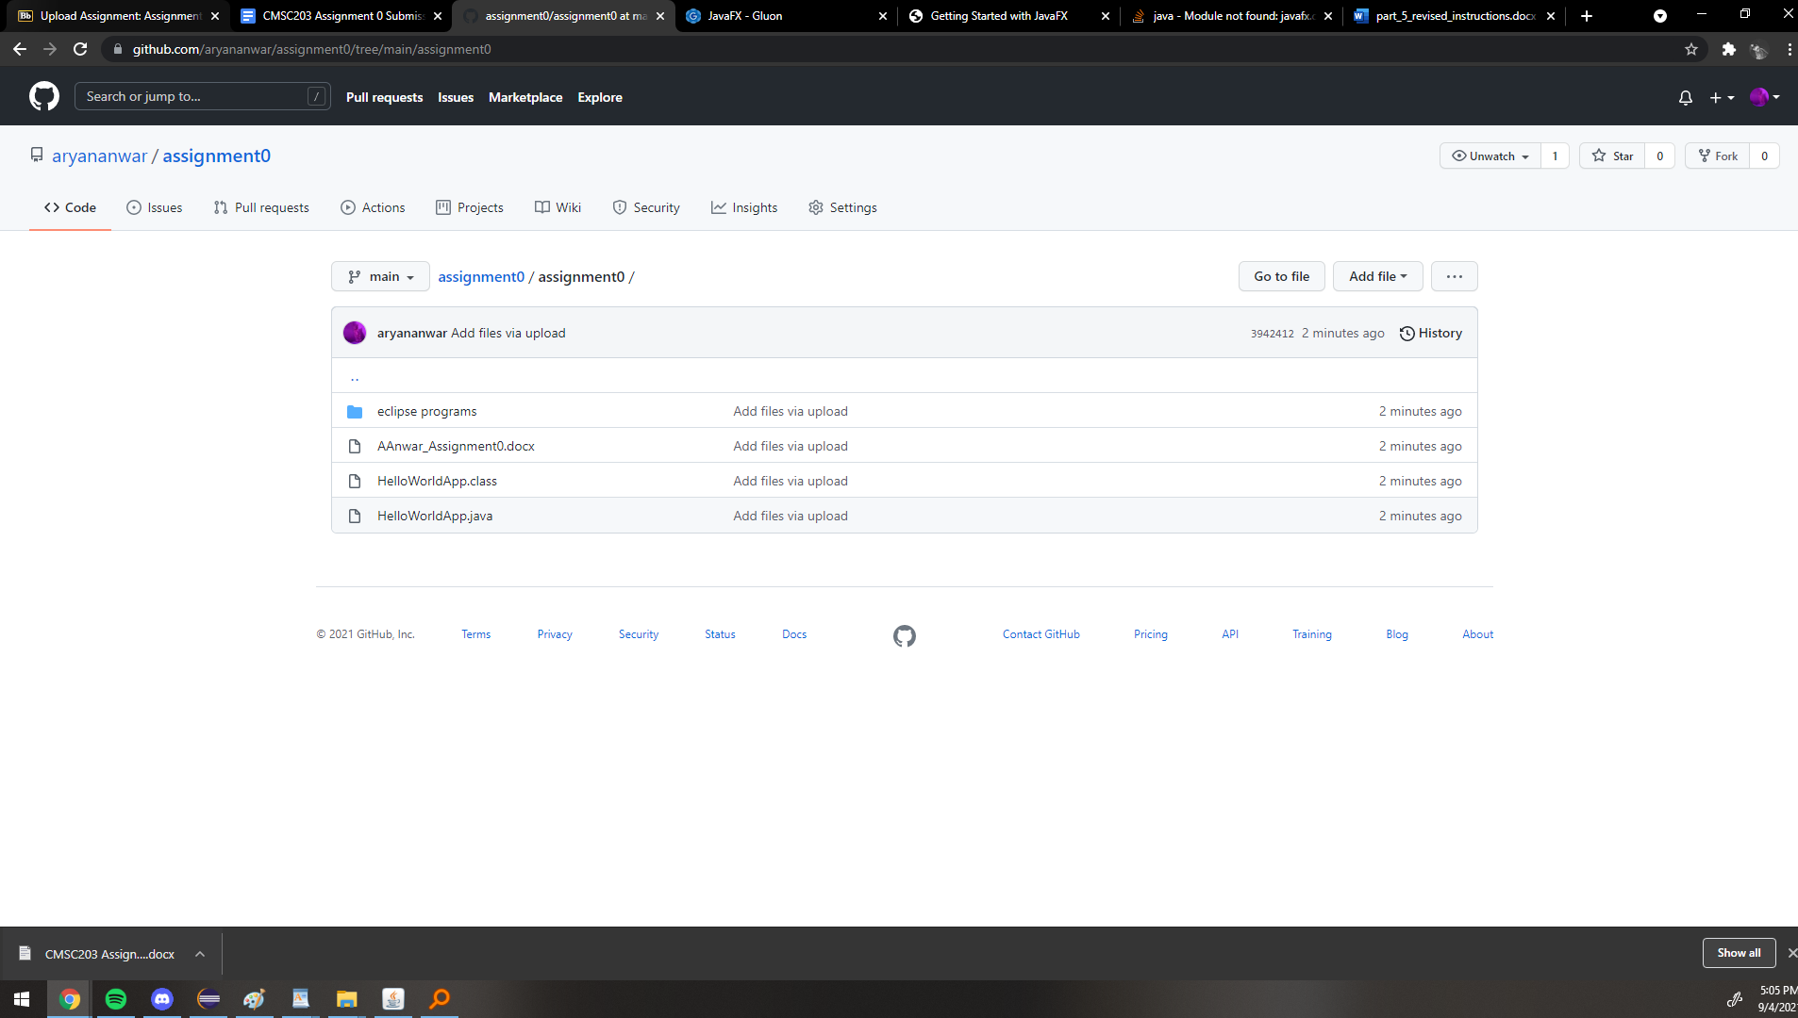

**Part 2 -Install JDK, Test java Application from Command Line**

Provide the screenshots from Step 1 and 2 here:

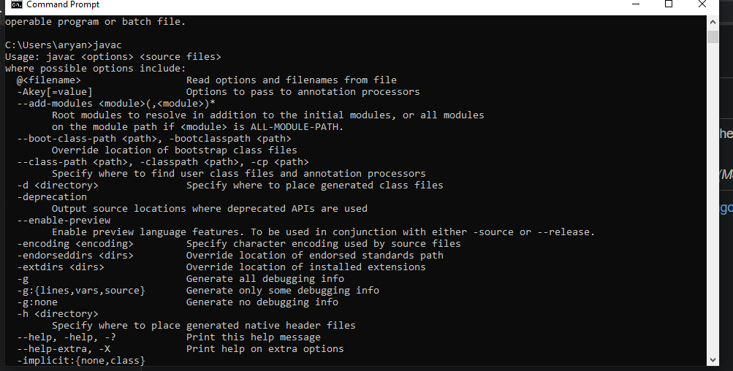

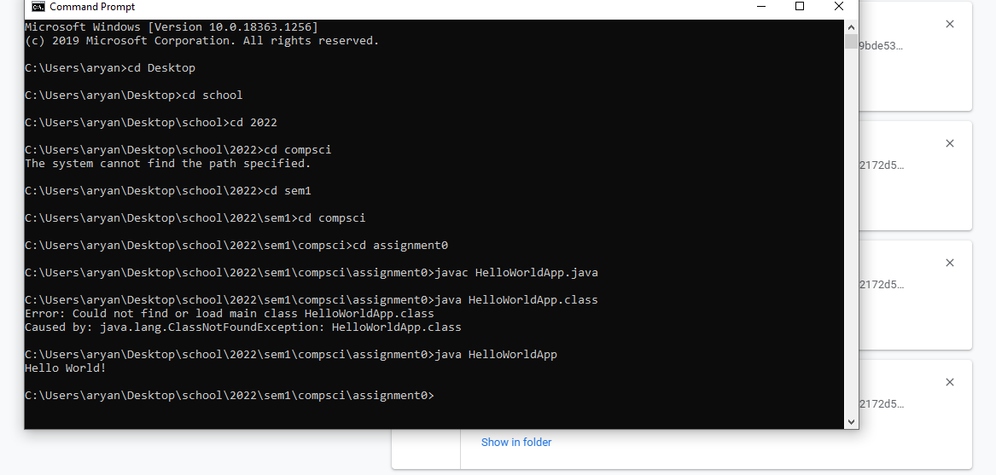

**Part 3 - Install Eclipse, Test Eclipse Java Application**

Provide the screenshots from Step 1 and 2 here:

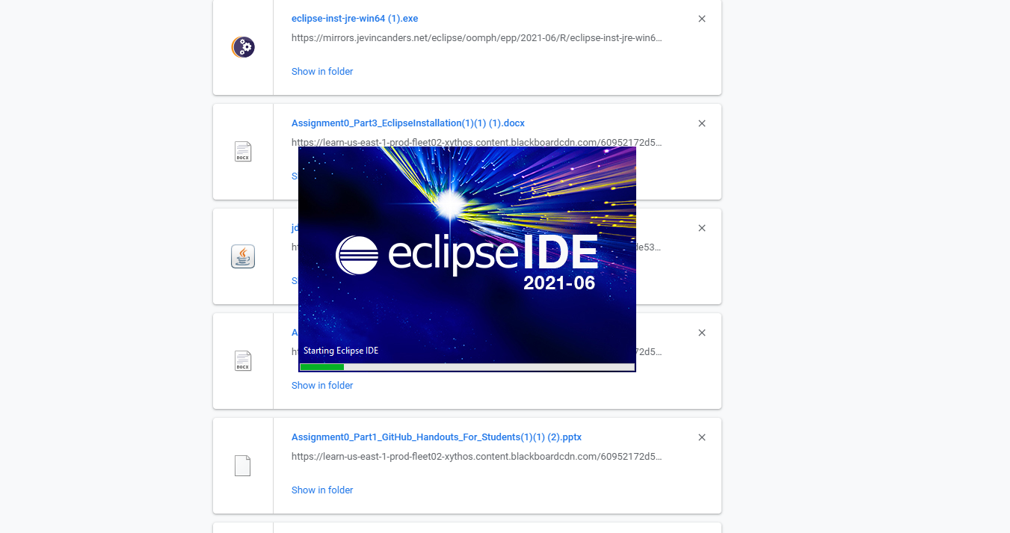

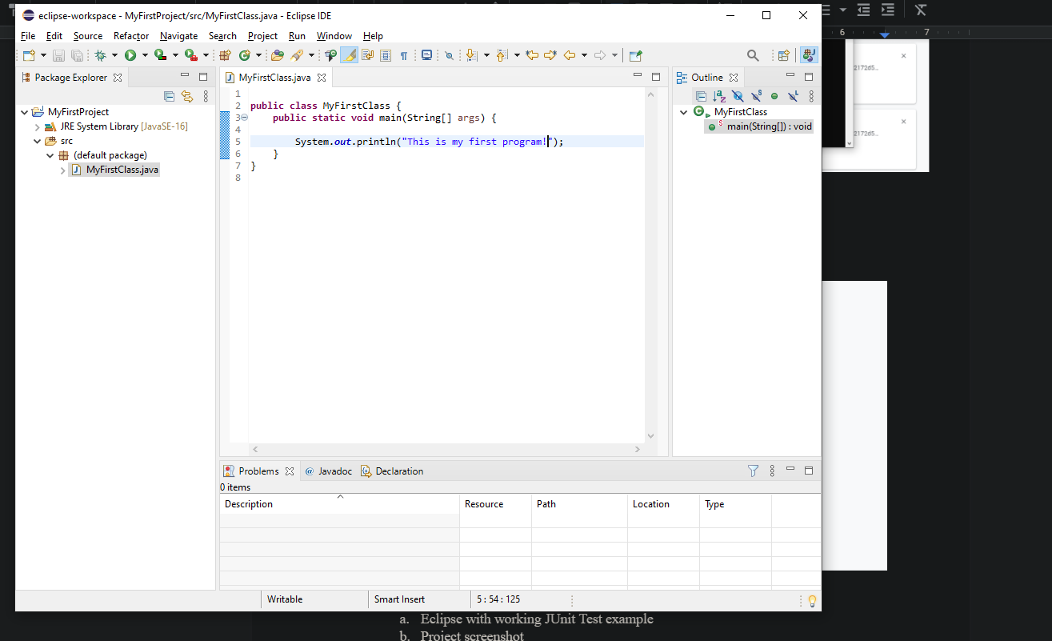

**Part 4 - Install, Setup, Test Junit Program.**

Provide the screenshots showing:

* 1. Eclipse with working JUnit Test example
  2. Project screenshot
  3. Running example screenshot

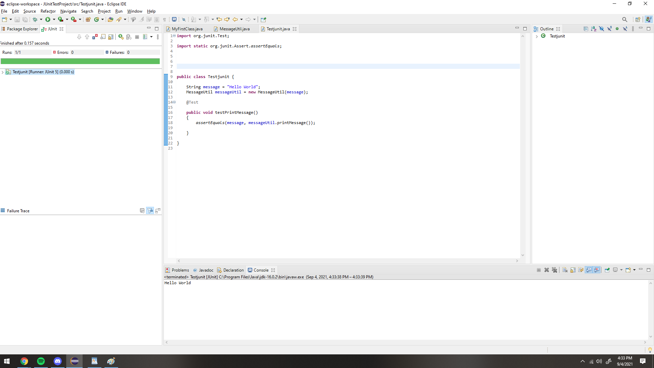

**Part 5 - Install, Setup, and Test JavaFX Application.**

Provide the screenshots showing:

1. JavaFX Project screenshot
2. Running example screenshot
3. Java Source Code File

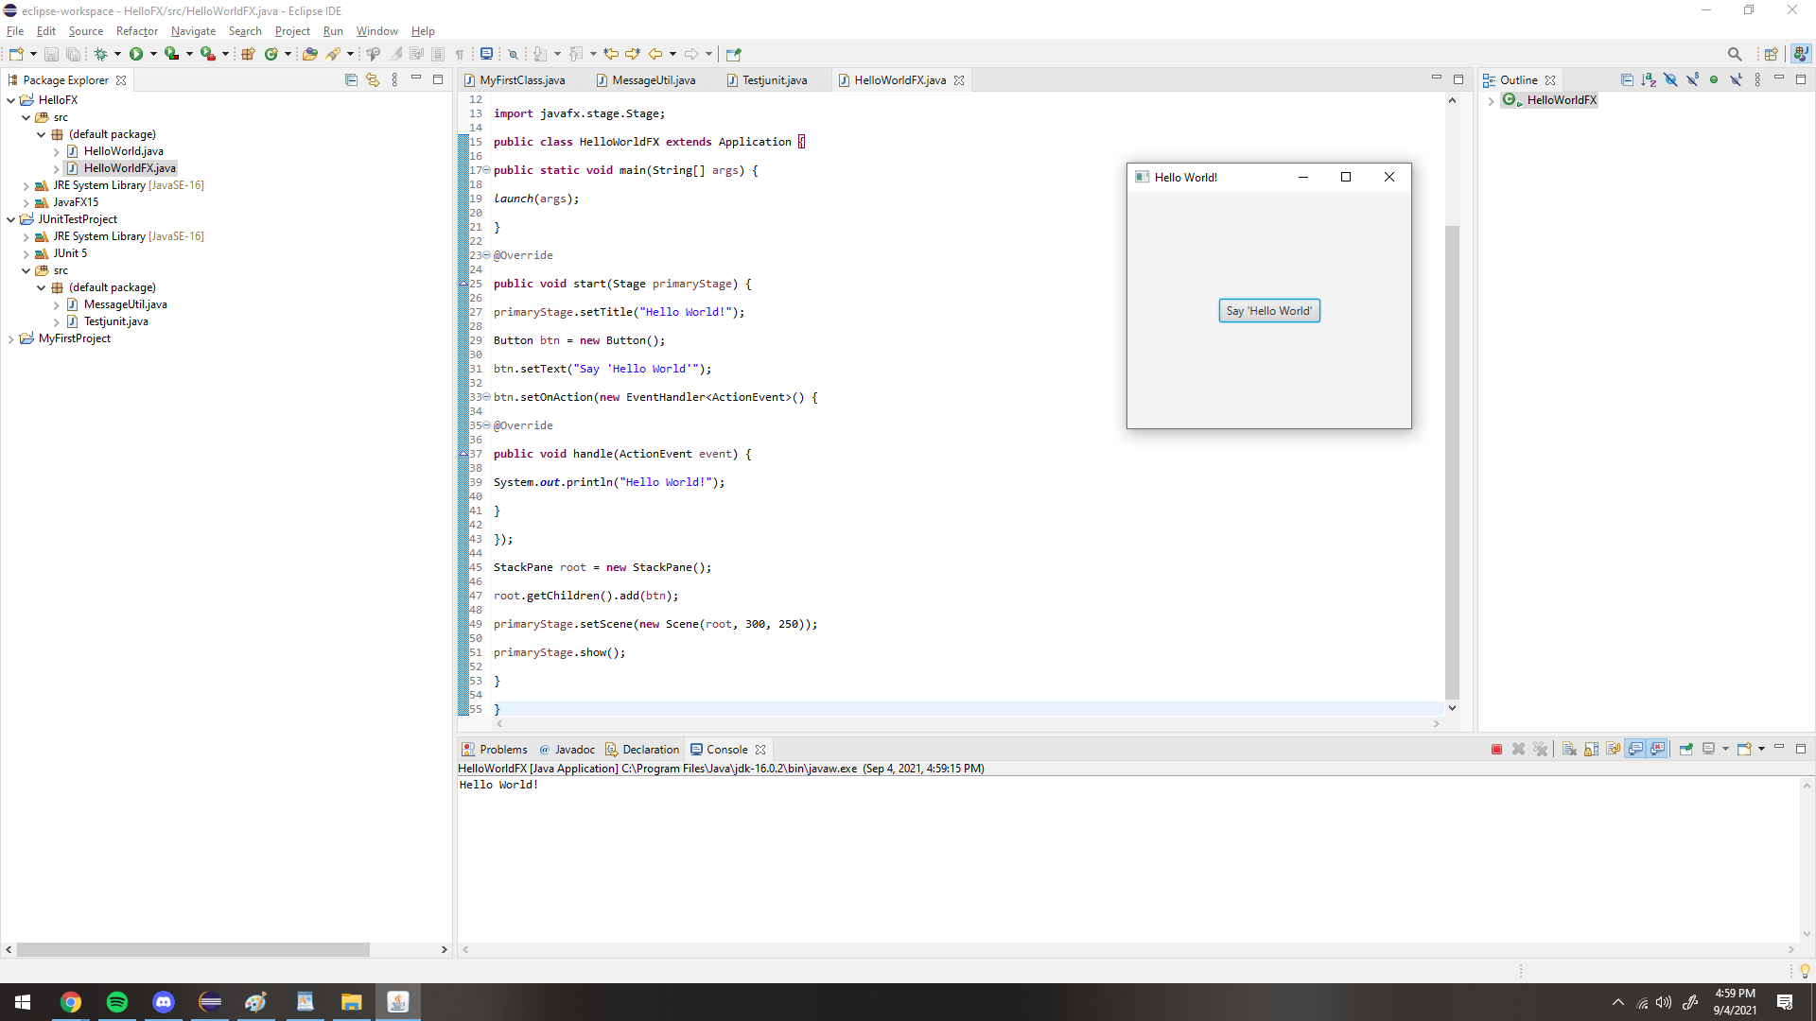

**Lessons Learned** <Provide answers to the questions listed below>**:**

Write about your Learning Experience, highlighting your lessons learned and learning experience from working on this assignment.

What have you learned?

I learned how to set up my computer to use Java.

What did you struggle with?

I struggled with the instructions as the instructions were very vague and I had to look online to resolve a lot of my issues.

What parts of this assignment were you successful with, and what parts (if any) were you not successful with?

I was successful with every part of this project.

Provide any additional resources/links/videos you used to while working on this assignment.

**https://stackoverflow.com/questions/54055598/module-not-found-javafx-controls**

**Check List:** <Provide answers to the column Y/N or N/A >**:**

| **#** |  | **Y/N** | **Comments** |
| --- | --- | --- | --- |
|  | **Assignment files:** |  |  |
|  | * FirstInitialLastName_Assignment0.docx/pdf | **Y** |  |
|  | * Source java files | **Y** |  |
|  | **Program compiles** | **Y** |  |
|  | **Program runs with desired outputs related to a Test Plan** | **Y** |  |
|  | **Documentation file: Screenshots of** |  |  |
|  | * Part1: Setup GitHub | **Y** |  |
|  | * Part 2 -Install JDK, Test java Application from Command Line | **Y** |  |
|  | * Part 3 - Install Eclipse, Test Eclipse Java Application | **Y** |  |
|  | * Part 4 - Install, Setup, Test Junit Program | **Y** |  |
|  | * Part 5 - Install, Setup, and Test JavaFX Application. | **Y** |  |
|  | * Lessons Learned | **Y** |  |
|  | * Checklist is completed and included in the Documentation | **Y** |  |